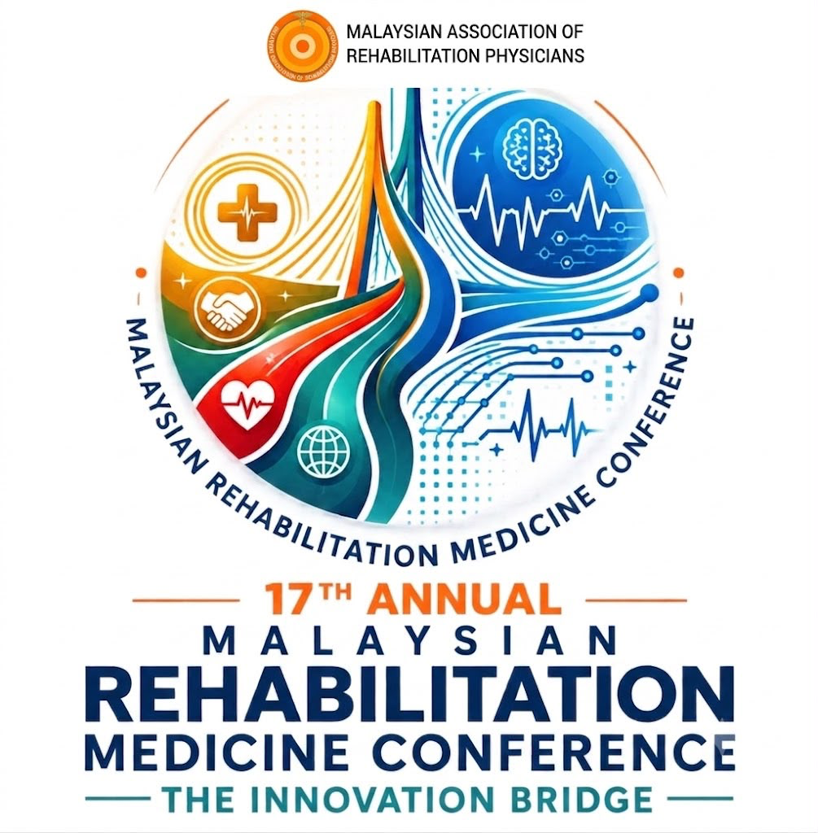

Rising Stars & Show-And-Tell

TERMS AND CONDITIONS
17ᵗʰ ANNUAL MALAYSIAN REHABILITATION MEDICINE CONFERENCE 2026
_________________________________________________________________________________________
Talented rehabilitation physicians are invited to submit executive summary to become the speakers for the Rising Stars and Show-and Tell slots.

Slot Date and Time
- 21 November 2026 (Saturday)
- Rising Stars : 1030 to 1130
- Show-and-Tell : 1130 to 1230

Slot Formats
- 15 minutes per speaker

We are looking for submissions in the following areas:
- Clinical Excellence: Challenging cases or innovative management strategies.
- Digital Integration: How you are using AI, apps, or telehealth to improve patient care.
- Service Improvement: Projects that enhance the efficiency or quality of your rehab unit.
- ⁠Research & Advocacy: Insights from recent studies or community outreach initiatives.

Submission Terms and Conditions

- Rising Stars speaker must be below 12 years of specialist service. No age limit for Show-and-Tell speaker.
- These slots are meant for single speaker. You may present on behalf of your team.
- Provide the executive summary of your presentation using the template provided.
- Submit in PDF format through the designated online submission form.
- Executive summary will be reviewed by the AMRMC Scientific Committee based on relevance, educational value, feasibility and suitability for the conference.
- The Scientific Committee will review all the submissions and deliberate the decision on which topic goes to which slot.
- There will be no speaker fee or hotel room reservation nor waiver of registration fee for speakers or those conducting workshops. It is purely voluntary.

Important: Only executive summaries submitted by the stated deadline will be considered.

Why Present?
- Professional Recognition: Selected speakers will receive a "Rising Star Presenter" Certificate.
- Mentorship: The best presentation (voted by the audience) will receive a special commendation during the closing ceremony.
- Networking: Gain visibility among senior consultants and association leadership.

